**CSCI 3033 OLA104**

Due: 11/11 (Monday), midnight (11:59)

**Objective**: JavaFX GUI application, random number, array, if statements, and logic operator.

**Problem**: Test your luck with this gambling device. The user inserts money and then presses a button. The app. then displays a set of random card images. If two or more of the images match, the user wins an amount of money that the app dispenses back to the user. Create an application that simulates this game. The figure below shows an example of how the app should look at run time. The application should let the user enter into a TextBox the amount of money he or she is inserting into the app. When the user clicks the Spin button, the application should display four randomly selected symbols. You need to use a minimum of 12 different images.

The program should also display the amount that the user won for the spin; the total amount won for all spins, and the total amount he spends in this game.

. 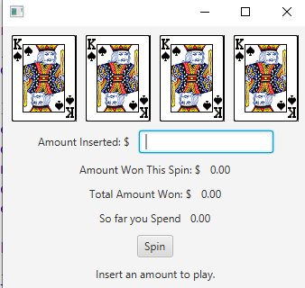

A screenshot shows a window displaying the application form at run time.

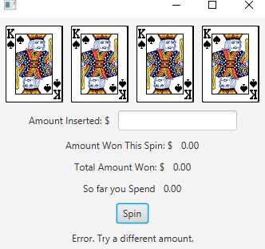

If the user clicks spin without entering an amount, an error message will show as the above figure.

If none of the randomly displayed images match, the program should inform the user that he or she has won $0. If two of the pictures match, the program should inform the user that he or she has won two times the amount entered. If three of the images match, the program should inform the user that he or she has won three times the amount entered.

How to submit the program

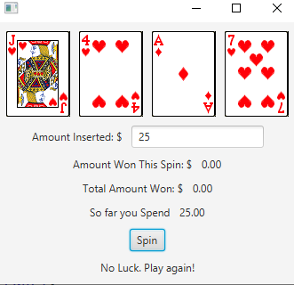

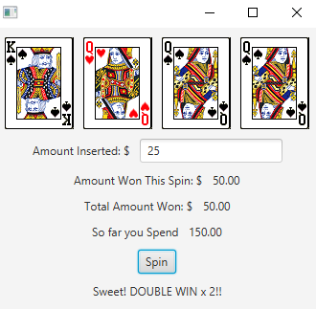

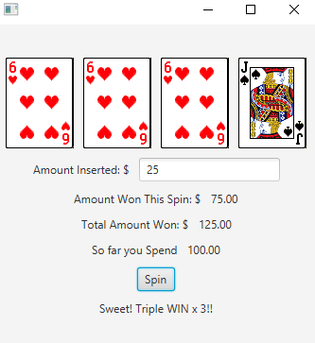

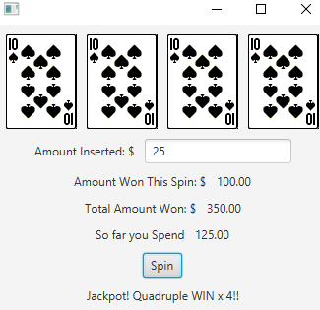

Submit your java file to OLA4 dropBox

1. Name your program <yourlastname>_OLA4. For example, if my last name were Carroll, then for me, it would be carroll_OLA4.
2. Compile and execute your project and make sure your assignment works appropriately.